H.T No
Regulations:
A18

Sreenidhi Institute of Science and Technology
(An Autonomous Institution)
Code No: 7AC02 Date: 23-Nov-2020 (FN)

B.Tech I-Year II-Semester External Examination, Nov/Dec - 2020 (Regular & Supplementary)
NETWORK ANALYSIS (ECM)

Time: 2 Hours Max.Marks:70

Note: a) No additional answer sheets will be provided.
b) All sub-parts of a question must be answered at one place only, otherwise it will not be valued.
c) Missing data can be assumed suitably.

ANSWER ANY 5 OUT OF 8 QUESTIONS. EACH QUESTION CARRIES 14 MARKS.

1. | a) | State Kirchhoff’s laws. | [6M]
 | b) | Using the Nodal Analysis, find the current through the resistors in the circuit configuration of the network shown below.  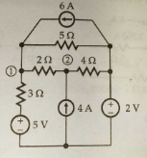 | [8M]
2. | a) | Define: i). Resonance frequency ii). Bandwidth iii). Q-factor iv). Selectivity | [8M]
 | b) | A series resonating circuit has R=1kΩ, half power frequencies of 10kHz and 90kHz. Determine the bandwidth and resonant frequency. Calculate the inductance and capacitance of the circuit. | [6M]
3. | a) | State and explain Faradays laws of electromagnetic induction. | [6M]
 | b) | Find the total inductance of the three series connected coupled coils in the figure below. Given that, L₁ = 1H; L₂ = 2H;L₃ = 5H;M₁₂ = 0.5H; M₂₃= 1H;M₁₃= 1H.  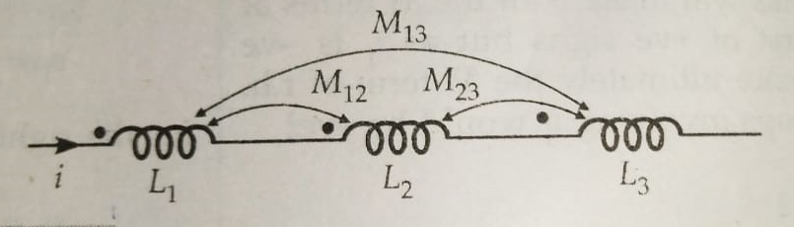 | [8M]
4. | a) | State Norton’s and Superposition Theorems. | [6M]
 | b) | Find “V_{L}” in the circuit using Superposition Theorem.  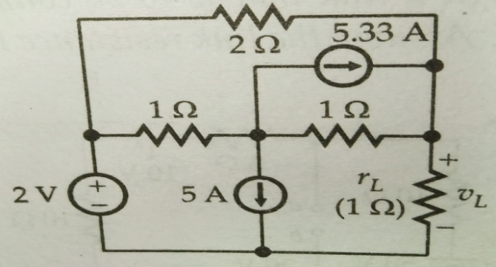 | [8M]
5. | a) | Derive and state the condition for reciprocity and symmetry in Y-parameter representation. | [7M]
 | b) | Two networks have been shown in the figure below. Obtain the transmission parameters of the resulting circuit when both the circuits are in cascade.  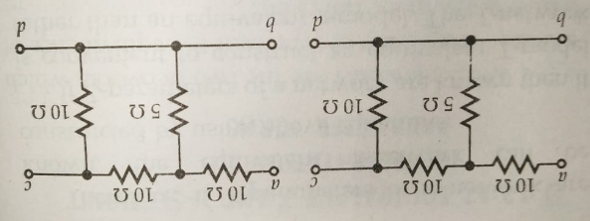 | [7M]
6. | a) | In a series RC circuit R = 1Ω and C = 0.5μF. An exponential voltage V = 10e^{-t} is suddenly applied at t = 0. Obtain i(t). Assume no initial charge in the capacitor. | [7M]
 | b) | In the circuit of the figure below, find i(t) at t=0⁺ following switching of “S” from (1) to (2). Assume steady state of the circuit while “S” was at (1).  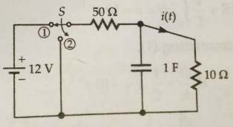 | [7M]
7. | a) | Obtain the current i₁ from the network shown below using Kirchhoff’s Voltage Law. | [7M]
 | b) | Find the power loss in the 10Ω resistor in the network shown below, using mesh Analysis.  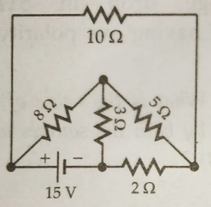 | [7M]
8. | a) | A 50µF capacitor, when connected in series with a coil having 40Ω resistance, resonates at 1000Hz. Find the inductance of the coil. Also obtain the circuit current if the applied voltage is 100V. Also calculate the capacitor and the coil at resonance. | [7M]
 | b) | A 220V, 100Hz ac source supplies a series LCR circuit with a capacitor and a coil. If the coil has 50mΩ resistance and 5mH inductance, find, at a resonance frequency of 100Hz, what is the value of capacitor? Also calculate the Q-factor and half power frequencies of the circuit. | [7M]

-- 00 -- 00 –

